Both stack and queue are types of linear data structures or abstract data types. Both are subsets of the List ADT (in array implementation) and these two have only some modifications in terms of data manipulation or input and output.

Stack follows the Last In, First Out (LIFO) structure order wherein the data that you last added to the data structure will be the first one to be deleted or popped when we try to manipulate the data inside it. We can only delete/insert data through the Top of Stack (TOS) which is commonly viewed as the length of the elements inside the data structure. Stack’s most common errors are Stack Underflow (trying to access data below the first index) and Stack Overflow (trying to access, insert, or remove data above the Stack’s max length).

On the other hand, Queue follows the First In, First Out (FIFO) structure order. Data manipulation includes Enqueuing and Dequeuing. The first elements / nodes to be enqueued are also the first nodes to be dequeued. We can only remove an element on one side and insert on the other side. Same common error for Queues are the Underflow and Overflow errors which means the index to be accessed are already out of range (higher than max length, lower than the head)

***Stacks***

Array implementation is simpler and quicker but is limited in size when declared statically.

|  |  |  |  |  |
| --- | --- | --- | --- | --- |
|  |  |  |  | TOP OF STACK |

Explanation 1:

Implementation for stack’s array implementation

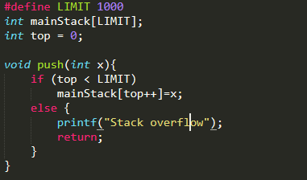

PUSH

|  |  |  |  |  |  |
| --- | --- | --- | --- | --- | --- |
|  |  |  |  |  | NEW TOP OF STACK |

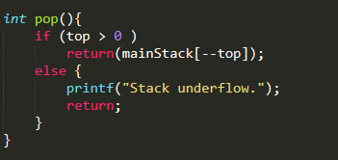Explanation 2:

POP

|  |  |  |  |  |
| --- | --- | --- | --- | --- |
|  |  |  |  | NEW TOP OF STACK |

***Queues***

**ENQUEUING**

|  |  |  |
| --- | --- | --- |
| HEAD  & TAIL | FREE | FREE |

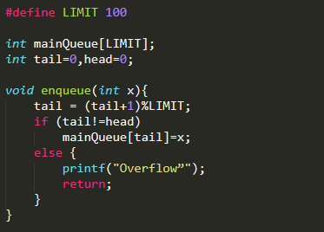

Enqueue

|  |  |  |
| --- | --- | --- |
| HEAD | TAIL | FREE |

Enqueue

|  |  |  |
| --- | --- | --- |
| HEAD |  | TAIL |

**DEQUEUING**

|  |  |  |
| --- | --- | --- |
| HEAD |  | TAIL |

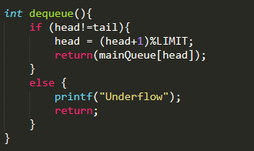

DEQUEUE

|  |  |  |
| --- | --- | --- |
| FREE | HEAD | TAIL |

DEQUEUE

|  |  |  |
| --- | --- | --- |
| FREE | FREE | HEAD  & TAIL |

Linked list implementation:

***Stacks***

Linked list implementation is more complex as you need to allocate memory for each node, but you have more control on memory allocation — removing the limitation in size.

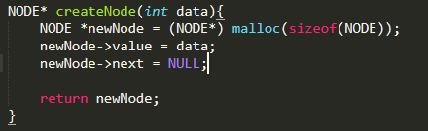

First, we declare the top of the stack and create new data for pushing.



***PUSH***

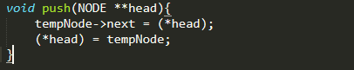We already created a node, so we will insert the created node at the head of the linked list every time we wish to push new data to the stack.

**TOP OF STACK**

**NEW NODE**

and then we update the top of stack



**TOP OF STACK**

***POP***

For popping, we just need to delete at head because we only add and delete nodes on one side if we are working on a stack. It is much easier to pop at head as we won’t need another pointer for maintaining the linkage of the list. Instead, we can use the head pointer.

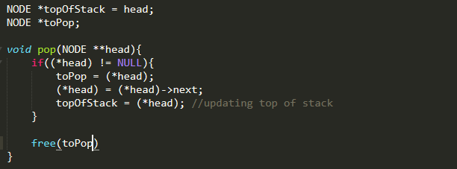

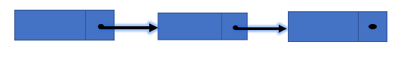



**TOP OF STACK**

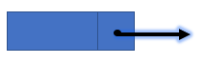

**toPop**

**TOP OF STACK**





**TOP OF STACK**

***QUEUES***

***Enqueuing***

2

1

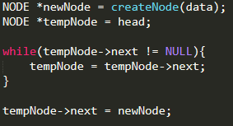

Enqueuing only happens on one side of the linked

list. It is more efficient to enqueue at the tail

than on the head.

**newNode**



2

3

1

***Dequeuing***

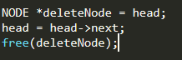Dequeuing is more efficient at head because

if it is done at the tail, we will need additional

pointer to keep track on the new tail if the current tail has been deleted or dequeued.



2

3





3

Common applications:

Queue:

As an ADT that uses FIFO data structure, it can be used to create programs with similar input-output process like bank queueing systems to organize waiting clients or for Call Center phone systems to hold calls until a Customer Service Representative is free.

According to Birch, it can also be used on Breadth First Search (BFS) wherein a queue can be used to store nodes that are to be processed. The adjacent node is added to a queue during processing to allow processing in the same order that they are viewed.

Additionally, the LRU cache implementation is essentially a queue structure, whilst a queue is not efficient enough on its own, one can be used to keep the order of cache items.

Stack:

The simplest application of a stack is to reverse a word. You push a given word to the stack and then create a new word by popping letter by letter from the stack. It also works in way like how “Undo” features work, or like the feature in a doubly linked list wherein we just change the current pointer to the ‘prev’ pointer to revert the changes that has been made.

It can also be used on Expression Conversion like Infix to Postfix, Postfix to Prefix, etc.

According to Sravani (2019), more advanced application of stacks can be used in Backtracking (game playing, finding paths, exhaustive searching), Memory management, run-time environment for nested language features, language processing and Parsing.

References:

[Sravani](https://www.quora.com/profile/Sravani-131), Btech Computer Science Engineering, National Institute of Technology, Andhra Pradesh,Tadepalligudem (2019) retrieved from <https://www.quora.com/What-are-the-real-applications-of-stacks-and-queues>

Birch, J. (2019), Data Structures: Stacks & Queues. Retrieved from <https://medium.com/@hitherejoe/data-structures-stacks-queues-a3b3591c8cb0>

https://www.studytonight.com/data-structures/queue-data-structure

Code snippets on Array Implementation are guided by Sir Arian Jacildo’s Lecture Slides on Array Implementation (CMSC 123)